Using this guide
This guide accompanies the National Treasury’s Strategic Procurement Framework (SPF) for Strategic Sourcing in the Public Sector. For more information, visit the National Treasury website at http://ocpo.treasury.gov.za/

TOTAL COST OF OWNERSHIP (TCO) ANALYSIS

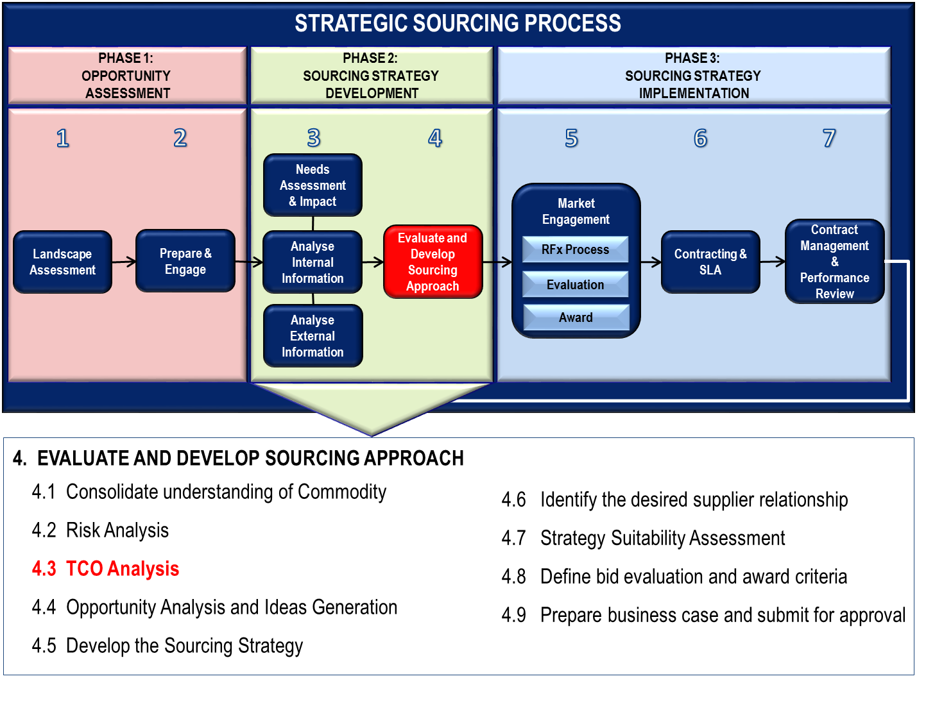
TCO analysis is done during Stage 4 of the Sourcing Strategy Development phase as part of evaluating and developing the sourcing approach. The objective of TCO analysis is to determine the direct and indirect costs of a product or service over its full life cycle (from procuring, installing, deploying, operating, upgrading, maintaining and disposal).

WHAT IS TOTAL COST OF OWNERSHIP?
Total Cost of Ownership (TCO) is an estimate of the total costs of goods, services or construction works over the whole of their life. It’s the combination of the purchase price plus all other costs you will incur, less any income you receive. For example: the initial purchase price plus installation costs, operating costs and ongoing maintenance less the residual value on disposal.

Why is TCO important?
The procurement principles encourage us to make balanced procurement decisions. This includes getting the best value for money. It means accounting for all costs and benefits over the lifetime of the goods or services. Part of good procurement is achieving the right price. Best value for money is the lowest whole-of-life cost. This involves identifying the initial purchase price and estimating all future costs and returns.
A procurement decision based on the initial purchase price only rather than the total costs over the whole-of-life, could fail to recognise the real costs to your department.

When should I use TCO?

TCO can be used at various stages in procurement:
- in a business case to assess the costs, benefits and risks associated with the procurement;
- when assessing different business models, maintenance options or solutions on a comparable cost basis;
- to understand the different cost drivers in the life of a procurement;
- by a supplier when bidding for a contract to demonstrate the total benefits and value being offered – especially where the initial purchase price is higher than competitors, but the total cost of ownership is lower;
- in selecting the best supplier by assessing the comparative whole-of-life costs of competing bids;
- in managing the contract to track actual expenses and income against budget; and
- as part of a benefits realisation exercise.

Is TCO only relevant to goods?
The concept of TCO is easy to understand in terms of goods, such as buying cars or leasing printers. It can also apply to services such as a building maintenance agreement or providing training.

TOTAL COST OF OWNERSHIP FRAMEWORK
The graphic below illustrates typical elements in the lifecycle of a commodity.
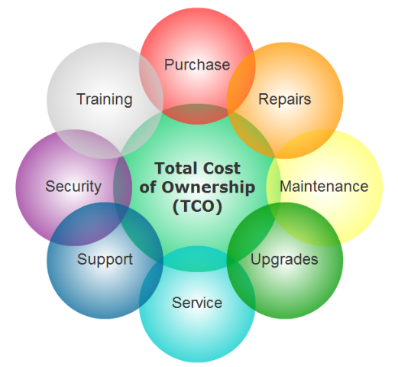

Tip of the iceberg
The initial purchase price is usually just the’ tip of the iceberg’ in terms of the costs you will incur. There are hidden costs lurking under the water line. You need to look beyond purchase price to identify all other expenses and income over the whole-of-life of the goods or service.
However, every procurement is different. So what needs to be included in the TCO calculation will vary. The goal is to arrive at a figure that accurately reflects the full costs and income to your department.
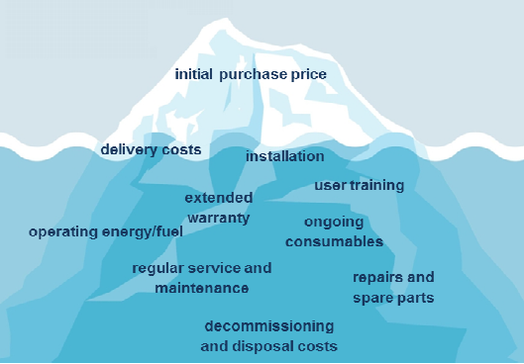

Types of costs
There are two broad types of costs:

Direct or “hard”costs
Direct costs are attributed to a specific good or service. In construction, the costs of materials used eg wood, cement, doors, fittings and labour are all direct costs.

Indirect or ‘soft’ costs.
Indirect costs are not attributed to a specific good or service. In manufacturing these include e.g. rent, taxes, maintenance of equipment, etc. Indirect costs are further broken down into:
- fixed costs (rent, insurance premiums, salaries)
- variable costs (electricity, paper, pens and other consumables, overtime).

Components that contribute to TCO.
Direct and indirect costs can fall within one of the following three categories:

External Cost
External costs are usually purchase or acquisition costs and all cost from the manufacturer up-to and including delivery to your warehouse.
- Purchase Price
- Inbound Freight Cost
- Insurance Premiums
- Packaging Cost
- Rate of Exchange
- Duties and Taxes

Internal Cost
All cost associated with the internal handling and management of the product (e.g. Installation, Support, Maintenance etc.)
- Transportation Cost (internally)
- Warehousing and Storage
- Manufacturing Cost
- Quality Assurance (internal)
- Installation Cost
- Operational Cost
- Training Cost
- Recovery and Disposal

Joint Cost
Joint supplier / client cost associated with administration, management and joint processes.
- Redesign and Development
- Other Joint Cost

Only those costs influenced by procurement and ownership of the commodity should be included. Use the Value Chain Analysis and Supply Chain Analysis that you did earlier to complete this exercise.

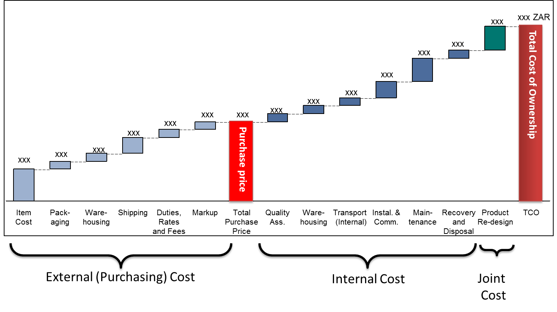

ADDRESSING OPPORTUNITIES IDENTIFIED FROM TCO ANALYSIS
Opportunities identified from Total Cost of Ownership analysis can be addressed through four (4) main levers:

Functional Excellence
- Exploit buying power
- Increase levels of competitive bidding
- Utilise strategic suppliers
- Pool purchases across departments
- Capture savings in departmental spend areas

Cross-functional Integration
- Alter specifications and reduce variants
- Change processes to allow for product substitution
- Reduce usage/demand for high-cost commodities

Organisational Capacity Building
- Create purchasing/category specialists
- Redesign Organisational linkages and incentives to ensure ongoing change
- Integrate purchasing to service delivery function

Supplier Integration
- Develop integrated strategic partnerships
- Redesign joint operational procedures
- Reassess make vs. buy decisions

